Fractals
Math 345
Henry Klaassen & Emily Scoular

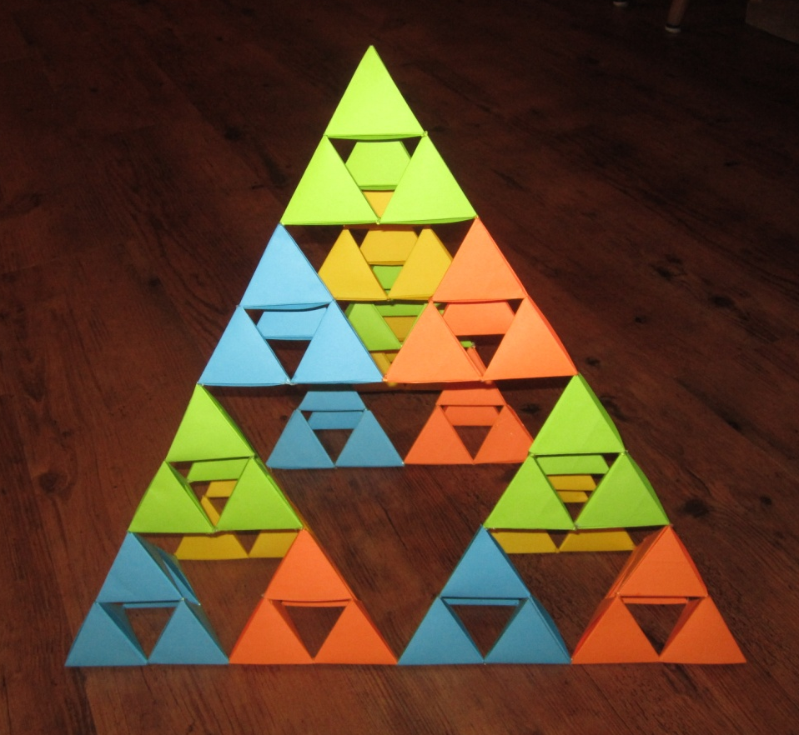

“Fractal geometry is a workable geometric middle ground between the excessive geometric order of Euclid and the geometric chaos of general mathematics.” -B. B. Mandelbrot
Introduction
One of the most recently discovered topics in geometry is the study of fractals. A fractal is an object that displays “self-similarity” at all scales, to infinity, meaning that an initial motif repeats itself on an ever-diminishing scale. This does not mean that the object displays the same type of structure at each scale, but the same type of structure must be displayed. Another way to describe a fractal is by stating that they are not differentiable anywhere. If there is a certain pattern at some place, that pattern is repeated an infinite amount of times at different places.
Various Fractals
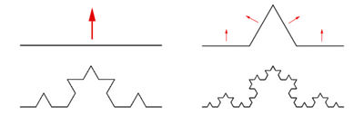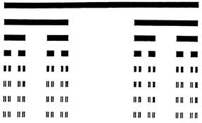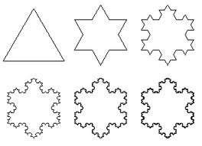The ideas of fractals began with the mathematician Leibnitz who spent some energy studying recursive self-similarity. Interestingly enough, he came to the conclusion that only a straight line can fill this description. In the late nineteenth century, finally there came some breakthroughs into these mathematical monsters. For instance, Cantor introduced the Cantor set, which is recognized as a fractal, and commonly accepted as the first fractal. At each level, the middle third of the straight lines in the row above are removed, leaving 2/3 of the previous line at each level. If this pattern continues down to infinity, theoretically there will eventually be an infinite amount of points, which are called “fractal dust”. Another common and early fractal is the Koch snowflake. It first appeared in a paper by the Swede Niels Fabian Helge von Koch in 1904. It begins with an equilateral triangle—essentially three identical straight lines joined at their ends—on which the straight lines at each level of scaling are treated in the same manner. With the line-point-line shape of the motif, the triangle quickly assumes the shape of a hexagon, hence the reference to the snowflake. At each level the snowflake becomes more and more apparent. A final example of these fractals is the “Sierpinski sieve” or Sierpinski triangle”. This amazing fractal was introduced by the Polish mathematician Vaclav Sierpinski in 1915. It is obtained by thinking of an equilateral triangle as a solid object. This is divided into four smaller equal-area equilateral triangles, and the middle one is removed. Thereafter, each of the left-over three triangles is treated as the initial triangle and the same procedure of removing the middle triangle is followed. This procedure can also be applied to a three-dimensional tetrahedron, where the middle shape removed is not a tetrahedron, but four tetrahedrons are left at each step, on which the procedure is performed.
Figure 3 - Constructing the Koch fractal on a straight line
Figure 1 - The Cantor Set
Figure 2 - Construction of the Koch snowflake
Generating the Mandelbrot Set
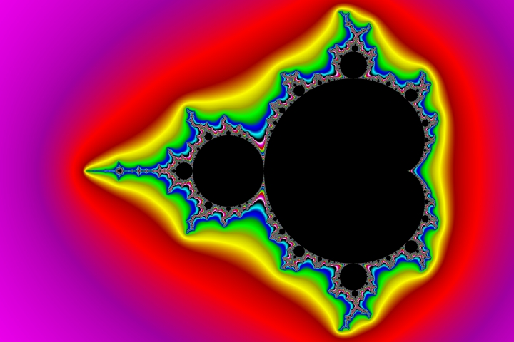The Mandelbrot set is so seemingly chaotic, complicated and detailed, and yet its algorithm is a simple formula:
Figure 4 – The Mandelbrot Set

Z_{n} = Z_{n-1}² + C

C is any point in the complex plane and Z₀ is taken as the origin. It is a recursive formula, which means the result is needed to calculate the next result that will follow. Z is classified as either going off towards infinity or converging to zero. Points that go to zero are said to be “in the Mandelbrot set” and are coloured black. Points that go off to infinity have “escaped” the Mandelbrot set and are coloured according to how fast they escaped.

Computer programs are the standard way to produce Mandelbrot sets and many other fractals like Julia sets or flame fractals. In this way, it is possible to do hundreds or even thousands of iterations and a variety of different colour schemes can be applied to produce beautiful pictures of fractals that weren’t possible before the invention of computers.

However, it can be useful to do a few low level iterations by hand to gain a better understanding of how the Mandelbrot set is created. You can begin with a simple 3x3 grid, where each square is two units wide, and the middle square is the origin of the complex plane.

-2+2i | 0+2i | 2+2i
-2+0i | 0+0i | 2+0i
-2-2i | 0-2i | 2-2i

Then carry out the recursive formula Z_{n} = Z_{n-1}² + C for each square, taking Z₀=0+0i. Because this representation of the Mandelbrot set is two units away from the origin, as soon as the magnitude of the complex number is greater than or equal to two, it will be considered to have “escaped” the set.

Example 1: C= -2+2i

Z_{n} = Z_{n-1}² + C
Z₀=0+0i
Z₁=(0+0i)² +(-2+2i) = -2+2i

||Z₁||= √2²+2² = √8 ≥ 2

So C escaped the Mandelbrot set after one iteration.

Example 2: C=0+0i

Z_{n} = Z_{n-1}² + C
Z₀=0+0i
Z₁=(0+0i)² +(0+0i) = 0+0i
Z₂=(0+0i)² +(0+0i)=0+0i
Z₃=(0+0i)² +(0+0i)=0+0i

So C never escapes the Mandelbrot set.

For the colouring scheme, we will use three colours: blue, orange and yellow. If Z escapes after one iteration, the square will be coloured blue, if it takes two iterations, it will be coloured orange, if it takes three or more to escape, the square will be coloured yellow. These colours are completely arbitrary, any could be used. If all nine squares are completed in this manner, the end result should be:

-2+2i | 0+2i | 2+2i
-2+0i | 0+0i | 2+0i
-2-2i | 0-2i | 2-2i

More detail is revealed if the number of squares are increased. So if we further subdivide each square into three, we get a 9x9 grid. Note, the calculations from the 3x3 grid don’t have to be redone. If the remaining squares are completed in the previous manner, the result should be:

 | -2 | -1.5 | -1 | -0.5 | 0 | 0.5 | 1 | 1.5 | 2
2i
1.5i
i
0.5i
0i
-0.5i
-i
-1.5i
-2i

Even at this crude level of detail, the beginnings of the Mandelbrot “bug” can be seen. By increasing the number of squares and broadening the colour scheme to more than just three colours, the familiar Mandelbrot set comes into view. Obviously, these calculations are too time consuming to complete by hand and fractals are primarily generated using computers.

Relevance of Fractals
If we consider fractals in the most objective way, they fit best in Affine Geometry. More specifically, fractals are based on a type of symmetry, namely the invariant figures under contraction and dilation. The main idea behind a fractal is its self-similarity at any level down to infinity. Since a similarity is a dilation followed by an isometry, each iteration in the construction of the fractal is an affine transformation. Technically we could do a discrete dilation at any magnification, and we’d produce the identical structure of what we started with. The equations we use to generate fractals, using the number of iterations and the magnification constant, can also be used in Euclidean geometry. When we take a line and split it as in the Cantor set, we throw away one-third of the original line at each iteration. However, if we kept the entire line--which is basically an identity, since the line doesn’t change--we’d be discussing Euclidean geometry, which deals with this type of figure.
While comparing these links them up, there are also many contrasts as well, some more prominent than others. Euclidean geometry is described by lines, ellipses, circles, etc.; but fractals are described by algorithms; they’re that much more complex. In addition to this, fractals do not deal in integer dimensions, as we’re used to with n-dimensional objects, but they deal in fractional dimensions. Therefore a fractal could have a dimension of 1.3058. As a matter of fact, one subgroup of fractals, the circle and sphere inversion fractals, have this dimension.

Sphere and circle inversion fractals tie into their own piece of geometry: inversion in a circle or in a sphere. Other types of fractals, such as hyperbolic fractals and the Kleinian group of fractals, use topics directed to the specific subgroup of geometries in which they fit.

Real Life Applications

Although there are still many discoveries to be made with fractal geometry, a large variety of useful real life applications have been found already. Fractals allow mathematicians to better model naturally occurring data and structures. Whereas traditional geometry is limited to ideal shapes and lines, fractals give the ability to express jagged lines and objects using simple formulas.

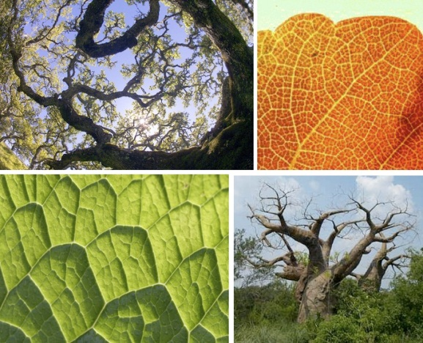
Continental coastlines, mountain ranges, clouds, water, trees, branches, leaves, and weather phenomena like hurricanes and tornados. Each of these natural shapes have certain properties that continually repeat again and again. Fractals can mimic these shapes, copy them over and over, and create realistic virtual landscapes. This is useful in computer animation for video games or movies, but also to model actual existing landscapes.

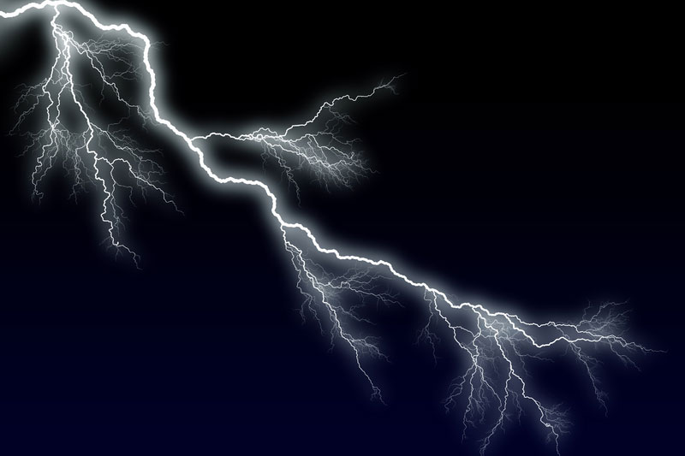
In biological sciences, graphical models of naturally occurring data don’t have to be expressed as a perfect sine waves or exponential functions anymore. For example, heart rate monitors display a heartbeat as a jagged line. Moreover, it is interesting to think that the more the world is “zoomed in,” the more living things we can find, like protists, bacteria, single cells, molecules. Like a fractal, the more you zoom in, the more detail is revealed. For example, a single chromosome is actually composed of tightly coiled chromatin which is further comprised of DNA. The nervous and circulatory systems are both comprised of extraordinary networks of nerves and capillaries of seemingly never-ending connectivity.

In the field of computer science, image compression has been a very big helpful use of fractals. Digital images can be rendered many times larger than their original size, revealing more detail. Fractals make data compression possible to store very large amounts of data in relatively small amounts of space.

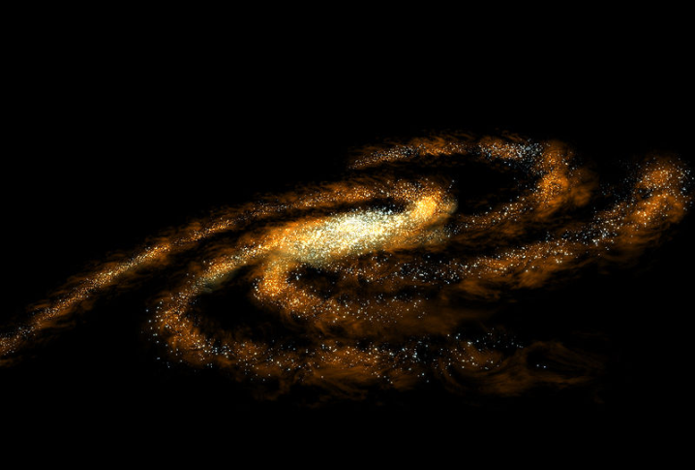
Fractals have also unlocked much potential with astrophysics and the study of celestial bodies in space. The question of how many stars are actually in the sky, whether the universe goes on forever, or if it eventually comes to an end are questions that could be answered one day with the help of fractals. The existence of fractals can lead to the debate of whether everything in nature can be reduced down to formulas, or whether true randomness still exists.

These are just a few applications of fractals, there really are countless more. And more will be discovered, it’s still a considered a new field of mathematics and it’s growing rapidly. Fractals are expected to usher in a new wave of technology in the coming years.

Sources:

The Colours of Infinity: the Beauty and Power of Fractals (DVD)
users.math.yale.edu/~bbm3/web_pdfs/fractalGeometryWhatIsIt.pdf
http://mathworld.wolfram.com/Fractal.html
http://mathforum.org/mathimages/index.php/Koch_Snowflake
http://library.thinkquest.org/3493/frames/fractal.html
http://www.hiddendimension.com/FractalMath/Mathematics_Main.html
http://www.fractal.org/Bewustzijns-Besturings-Model/Fractals-Useful-Beauty.htm
http://jcomeau.unternet.net/
http://www.h-schmidt.net/MandelApplet/mandelapplet.html

Lauwerier, Hans. Fractals: Endlessly Repeated Geometrical Figures. Princeton University Press, 1991.

Peitgen, Jürgens, Saupe. Fractals for the Classroom. Springer-Verlag.

